**WEEK 4:**

**S.NO:1 CREATE A SPRING WEB PROJECT USING MAVEN**

**SOLUTION:**

**package** com.cognizant.spring_learn;

**import** org.springframework.boot.SpringApplication;

**import** org.springframework.boot.autoconfigure.SpringBootApplication;

@SpringBootApplication

**public** **class** SpringLearnApplication {

**public** **static** **void** main(String[] args) {

SpringApplication.*run*(SpringLearnApplication.**class**, args);

System.***out***.println("SpringLearnApplication started successfully!");

}

}

**OUTPUT:**

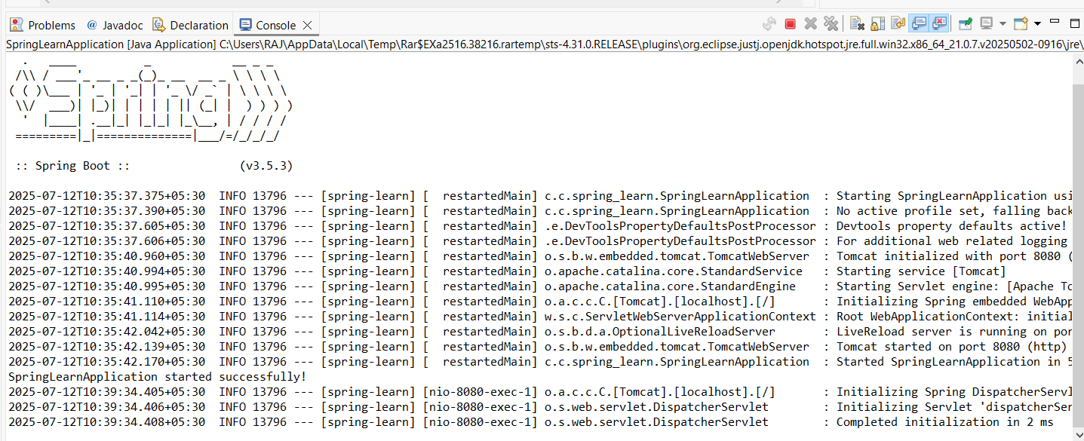

**S.NO:2 Spring Core – Load Country from Spring Configuration XML**

**SOLUTION:**

package com.cognizant.springlearn;

import org.slf4j.Logger;

import org.slf4j.LoggerFactory;

import org.springframework.context.ApplicationContext;

import org.springframework.context.support.ClassPathXmlApplicationContext;

public class SpringLearnApplication {

private static final Logger LOGGER = LoggerFactory.getLogger(SpringLearnApplication.class);

public static void main(String[] args) {

LOGGER.debug("Start main");

ApplicationContext context =

new ClassPathXmlApplicationContext("country.xml");

Country country = (Country) context.getBean("country"); // No markers if everything is resolved

LOGGER.debug("Loaded Country: {}", country);

LOGGER.debug("End main");

}

}

**OUTPUT:**

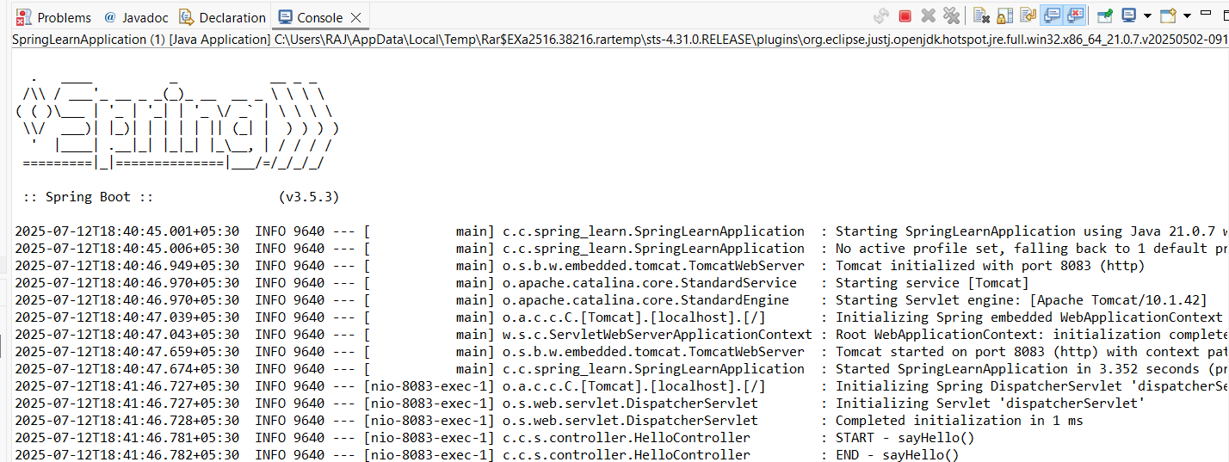

S.NO:3 **Hello World RESTful Web Service**

**SOLUTION**:

**package** com.cognizant.spring_learn.controller;

**import** org.slf4j.Logger;

**import** org.slf4j.LoggerFactory;

**import** org.springframework.web.bind.annotation.GetMapping;

**import** org.springframework.web.bind.annotation.RestController;

@RestController

**public** **class** HelloController {

**private** **static** **final** Logger ***LOGGER*** = LoggerFactory.*getLogger*(HelloController.**class**);

@GetMapping("/hello")

**public** String sayHello() {

***LOGGER***.info("START - sayHello()");

String message = "Hello World!!";

***LOGGER***.info("END - sayHello()");

**return** message;

}

}

**OUTPUT:**

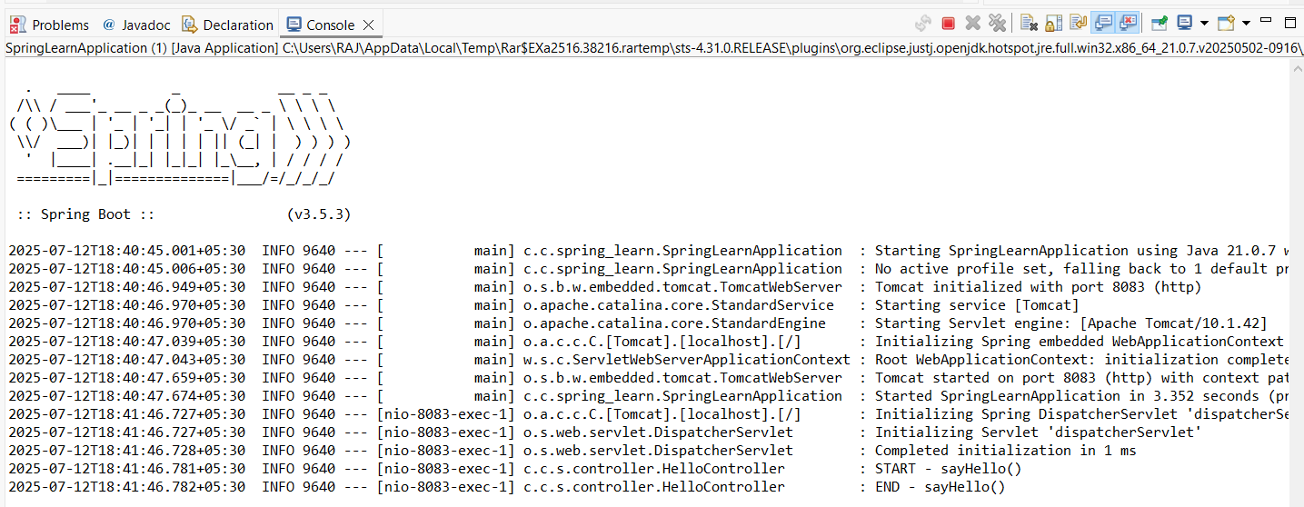

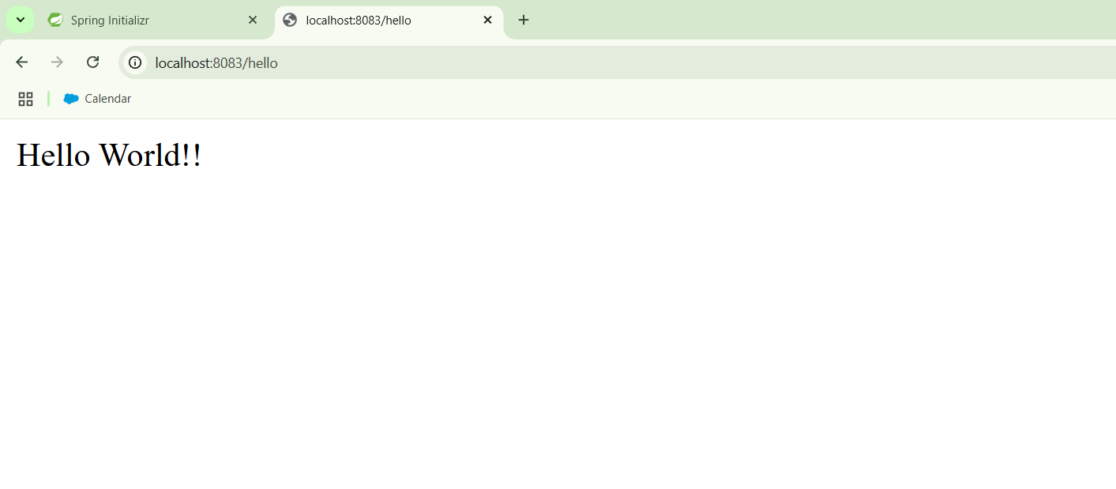**S.NO:4 REST - Country Web Service**

**SOLUTION:**

package com.cognizant.spring-learn.controller;

import com.cognizant.spring-learn.model.Country;

import org.springframework.context.ApplicationContext;

import org.springframework.context.support.ClassPathXmlApplicationContext;

import org.springframework.web.bind.annotation.RequestMapping;

import org.springframework.web.bind.annotation.RestController;

@RestController

public class CountryController {

@RequestMapping("/country")

public Country getCountryIndia() {

ApplicationContext context = new ClassPathXmlApplicationContext("country.xml");

Country country = (Country) context.getBean("country");

return country;

}

}

OUTPUT:

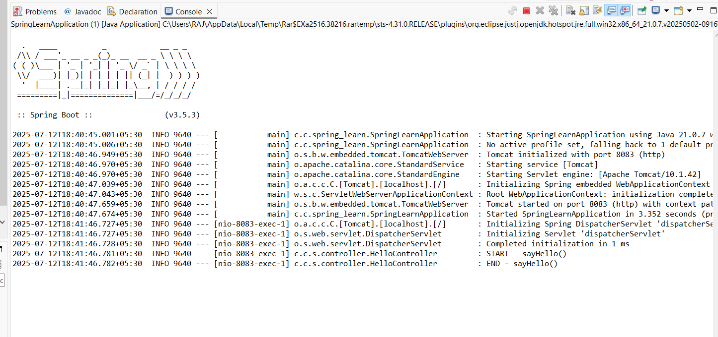

**S.NO:5 REST - Get country based on country code**

SOLUTION :

**package** com.cognizant.spring.learn;

**import** org.springframework.boot.SpringApplication;

**import** org.springframework.boot.autoconfigure.SpringBootApplication;

@SpringBootApplication

**public** **class** Application {

**public** **static** **void** main(String[] args) {

SpringApplication.run(Application.**class**, args);

}

}

OUTPUT:

